Manshaa Kakani | BE: II Year | Information Technology (IT): A

Operating System Lab Assignment: II

[4ITRC2]

Table of Contents

▪ Aim of assignment 1

▪ To Perform 1

▪ To Submit 1

Outputs of the following commands 1

Answers to the following Questions: (you need to supply commands) 3

# Aim of assignment

To study and understand Ubuntu commands.

# To Perform

Execute different commands.

# To Submit

### Outputs of the following commands

* 1. pwd



* 1. cd

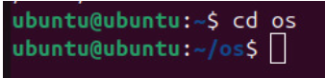

* 1. ls



* 1. mkdir



* 1. rm



* 1. touch



* 1. hostname



* 1. cat

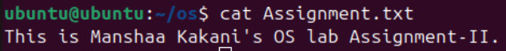

* 1. chmod



* 1. echo



* 1. grep



* 1. fgrep



* 1. mv

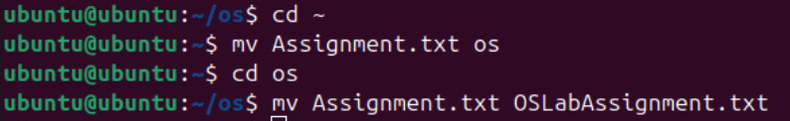

* 1. cp



* 1. more

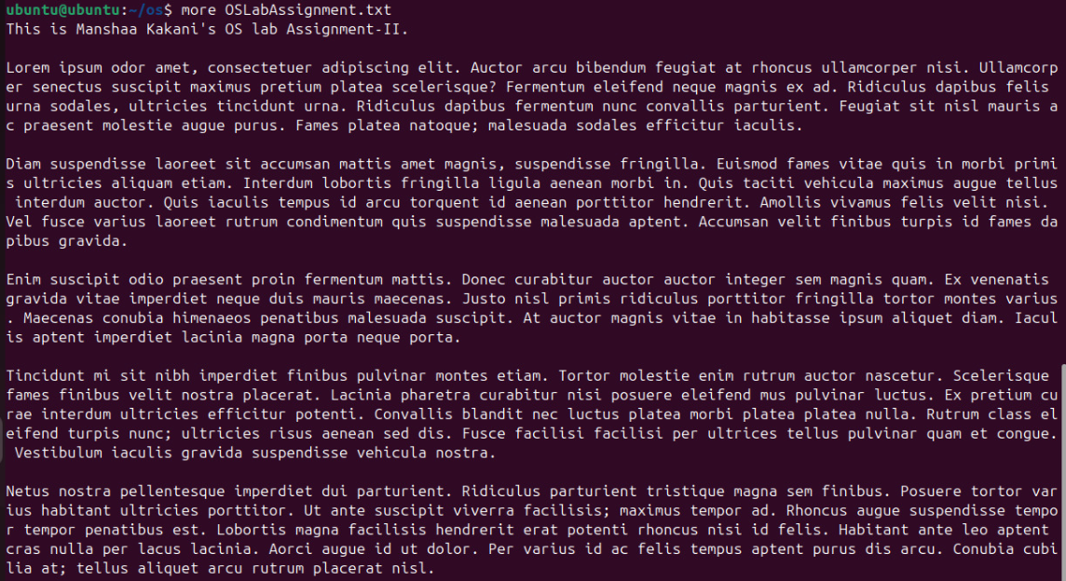

* 1. less

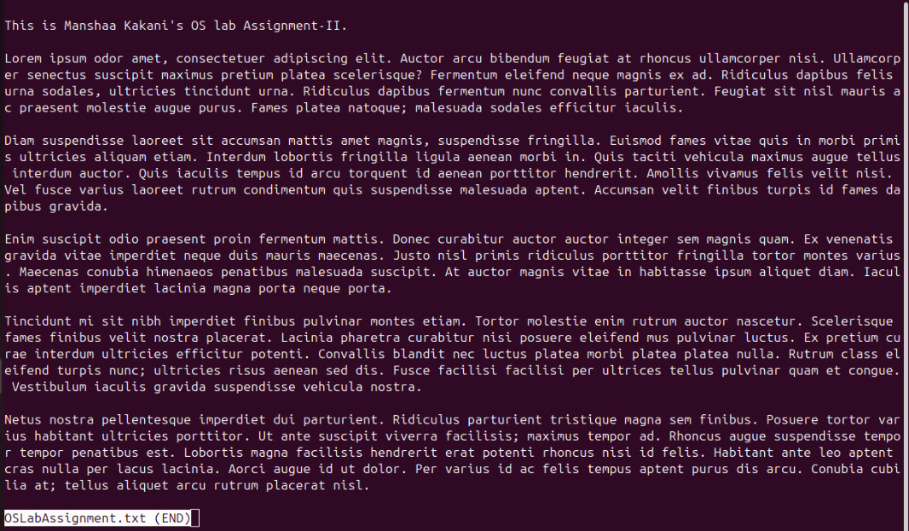

* 1. wc



* 1. awk



* 1. sed



* 1. tail

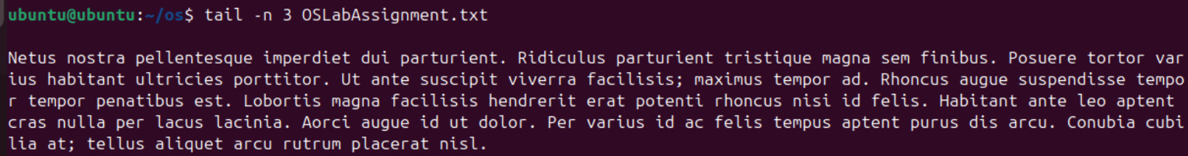

### Answers to the following Questions: (you need to supply commands)

1. How to navigate to a Specific Directory?

To navigate to a specific directory, use the cd command:

**cd /path/to/directory**

Change to home directory:

**cd ~ or just cd**

Go up one level:

**cd ..**

1. How to see detailed information about files and directories using ls?

For detailed information about files and directories, use ls with the -l flag:

**ls -l**

This will list the file permissions, number of links, owner, group, size, date/time, and name.

If you wish to see hidden files too:

**ls -la**

1. How to create multiple directories in Linux using `mkdir` command?

We can create multiple directories with a single command by listing all directory names:

**mkdir dir1 dir2 dir3**

1. How to remove multiple files at once with rm?

**rm file1.txt file2.txt file3.txt…**

If you want a prompt before removal:

**rm -i file1.txt file2.txt…**

If you want to force remove without prompting:

**rm -f file1.txt file2.txt…**

1. Can rm be used to delete directories?

Yes, but you need to use the -r along with rm:

**rm -r directoryname**

For empty directories, you can also use rmdir:

**rmdir directoryname**

1. How Do You Copy Files and Directories in Linux?

To copy files:

**cp sourcefile.txt destination path**

To copy directories (with all contents), use the -r flag:

**cp -r sourcedir destinationdir**

1. How to Rename a file in Linux Using mv Command

**mv oldname.txt newname.txt**

1. How to Move Multiple files in Linux Using mv Command

To move multiple files, list all the files you want to move with the destination directory at the end:

**mv file1.txt file2.txt file3.txt… destinationdir/**

1. How to Create Multiple Empty Files by Using Touch Command in Linux

This command creates multiple empty files or updates the timestamp if the files already exist.

**touch file1.txt file2.txt file3.txt…**

1. How to View the Content of Multiple Files in Linux

Using cat for multiple files:

**cat file1.txt file2.txt file3.txt**

1. How to Create a file and add content in Linux Using `cat` Command

**cat > filename.txt**

**…File Content…**

Press Ctrl+D when done.

1. How to Append the Contents of One File to the End of Another File using cat

command

**cat sourcefile.txt >> destinationfile.txt**

1. How to use cat command if the file has a lot of content and can’t fit in the

terminal.

Use less instead of cat if the file has a lot of content and can’t fit in the terminal:

**less filename.txt**

1. How to Merge Contents of Multiple Files Using `cat` Command

**cat file1.txt file2.txt file3.txt… > mergedfile.txt**

1. How to use cat Command to Append to an Existing File

**cat >> filename.txt**

**…Type content here…**

Press Ctrl+D when finished.

1. What is “chmod 777 “, “chmod 755” and “chmod +x “or “chmod a+x”?

Each digit represents permissions for the user, group, and others, respectively. And each digit is a sum of the following values:

* 4: Read (r)
* 2: Write (w)
* 1: Execute (x)

So,

chmod 777: Gives read, write, and execute permissions to owner(4+2+1), group(4+2+1), and others (4+2+1)

chmod 755: Gives read, write, execute to owner(4+2+1); read and execute to group(4+1) and others(4+1)

chmod +x: Adds execute permission for the current permission set

chmod a+x: Adds execute permission for all (owner, group, others)

1. How to find the number of lines that matches the given string/pattern

**grep -c "pattern" filename.txt**

1. How to display the files that contains the given string/pattern.

**grep -l "pattern" file1.txt file2.txt file3.txt…**

Or for all files in a directory:

**grep -l "pattern" \***

1. How to show the line number of file with the line matched.

**grep -n "pattern" filename.txt**

1. How to match the lines that start with a string using grep

**grep "^string" filename.txt**

1. Can the ‘sort’ command be used to sort files in descending order by default?

No, by default sort arranges lines in ascending order. To sort in descending order:

**sort -r filename.txt**

1. How can I sort a file based on a specific column using the ‘sort’ command?

Use the -k to specify the column:

**sort -k column_number filename.txt**